**Output:**

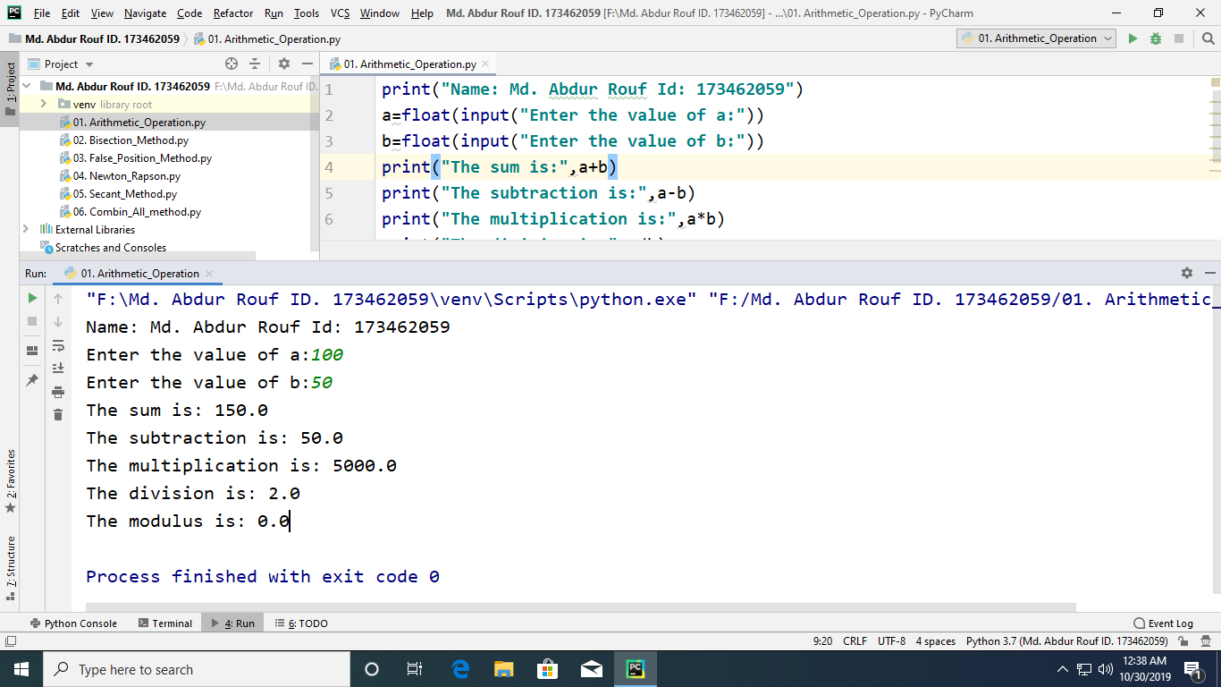

Figure: Implementation of Output All Arithmetic Operation in Python

**Output:**

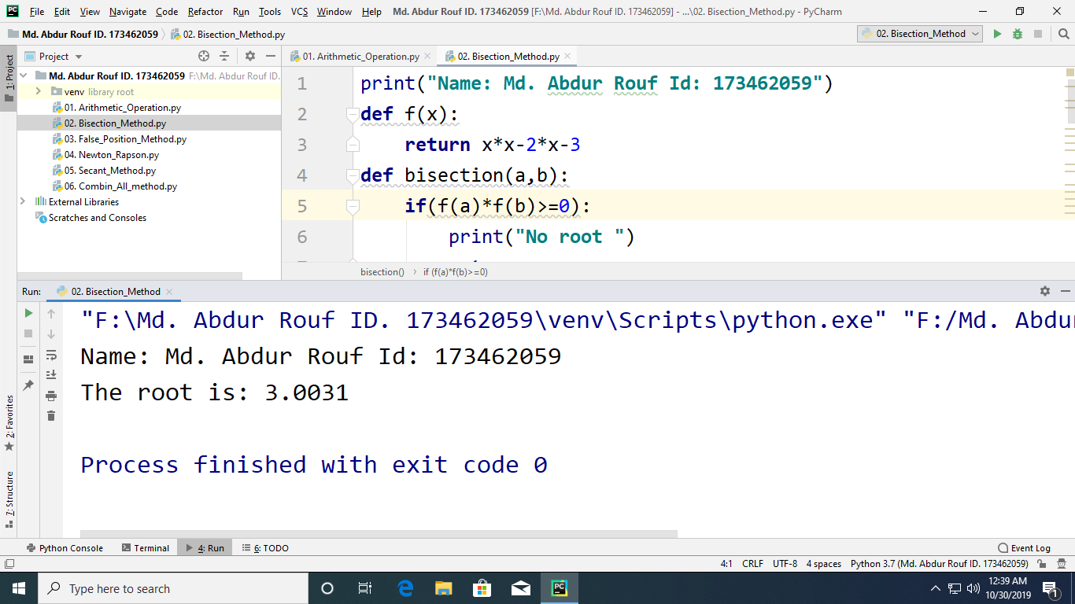

Figure: Implementation of Output Bisection Method in Python

**Output:**

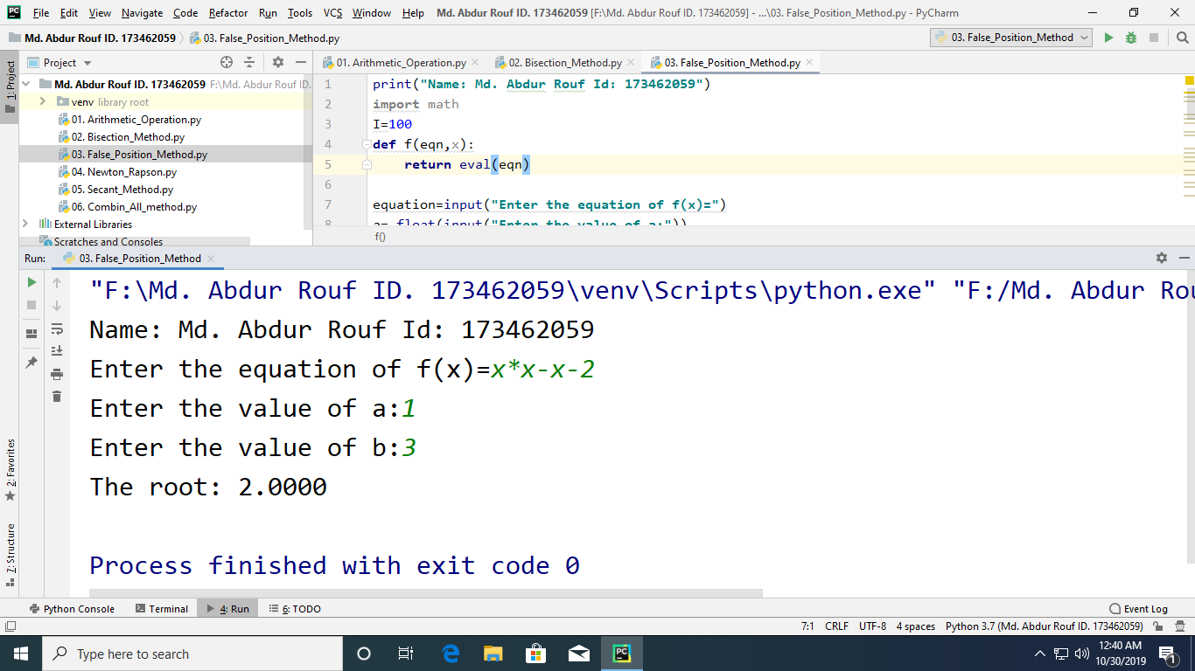

Figure: Implementation of Output False-Position Method in Python

**Output:**

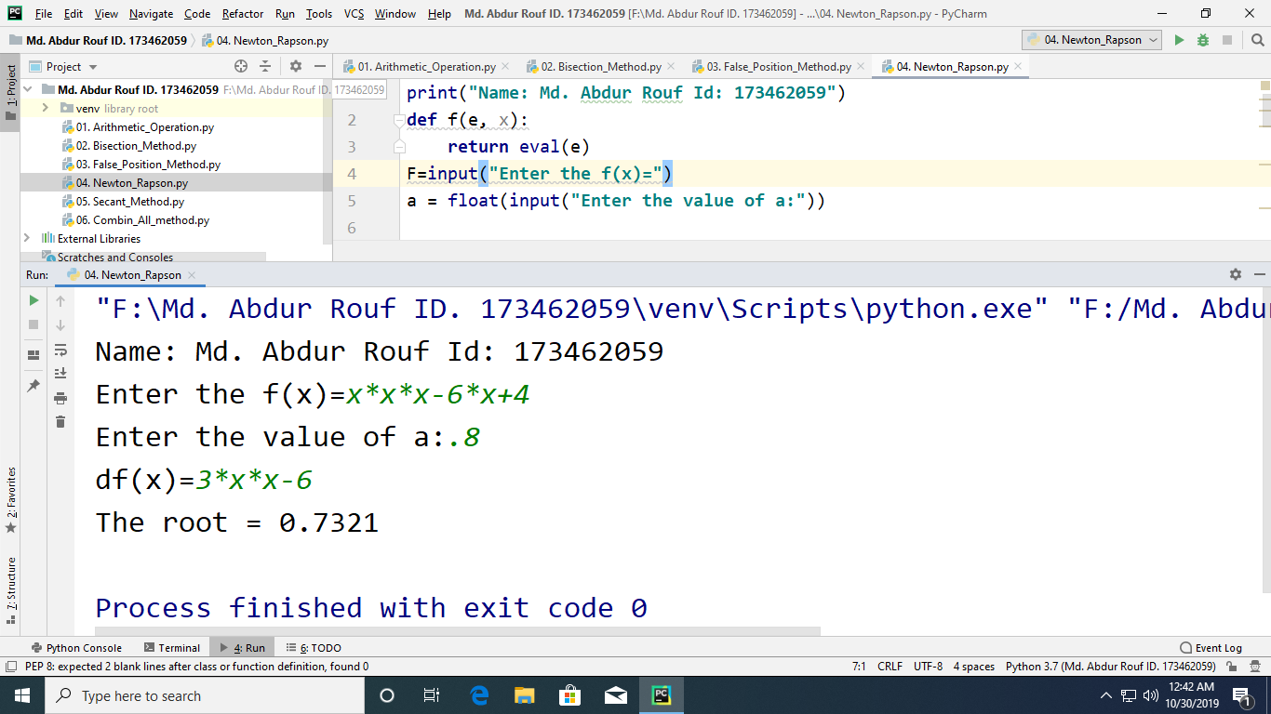

Figure: Implementation of Output Newton Raphson Method in Python

**Output:**

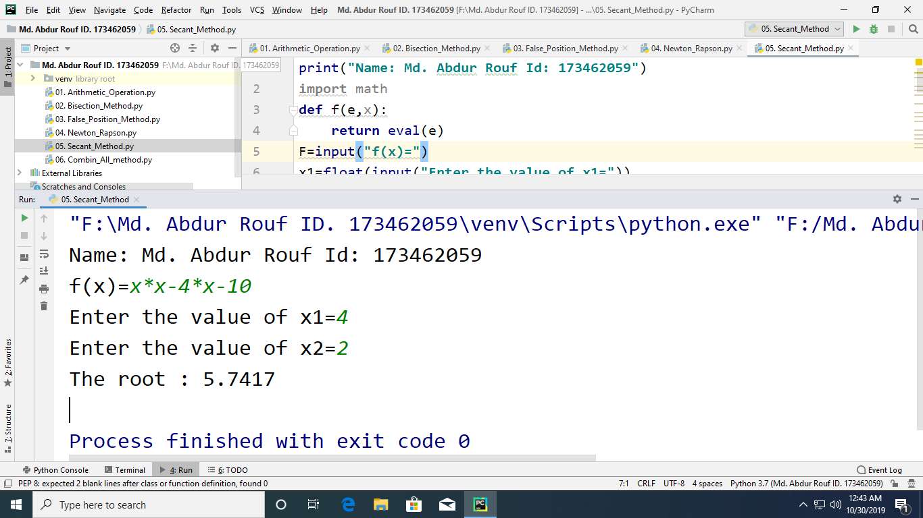

Figure: Implementation of Output Secant Method in Python

**Output:**

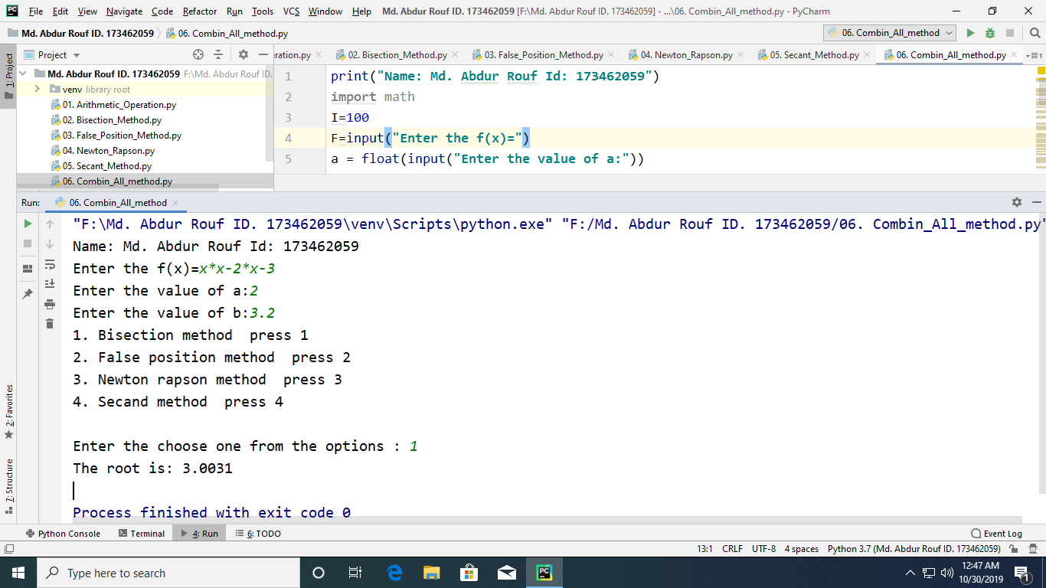

Figure: Implementation of Output Different Methods to Find the Root of a Nonlinear Equation in Python

**Output:**

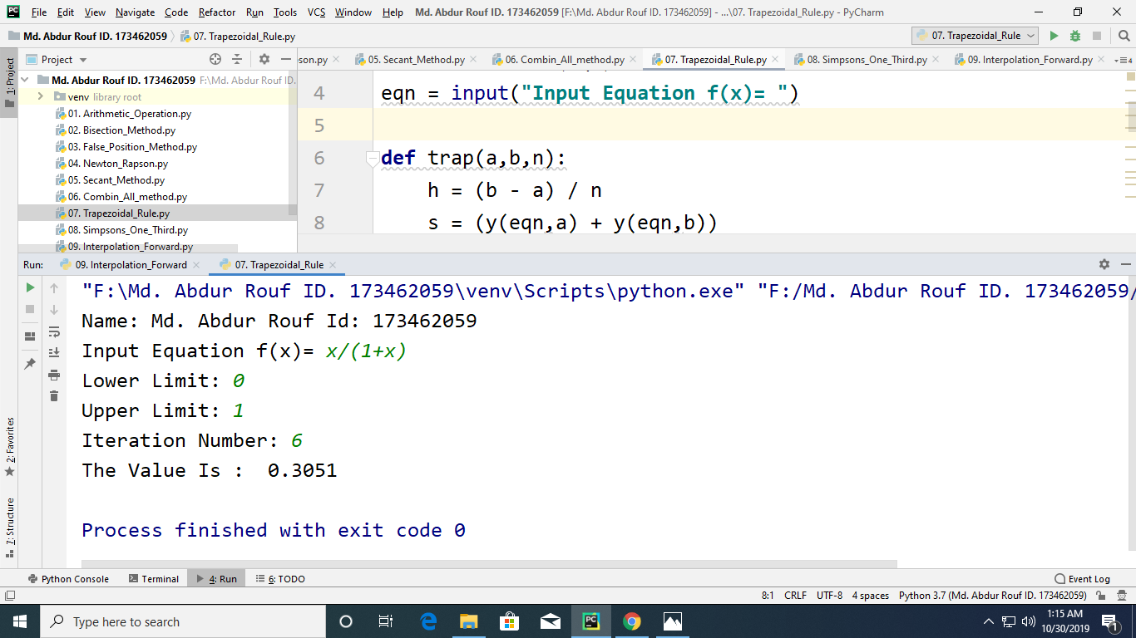

Figure: Implementation of Output Trapezoidal Rule in Python

**Output:**

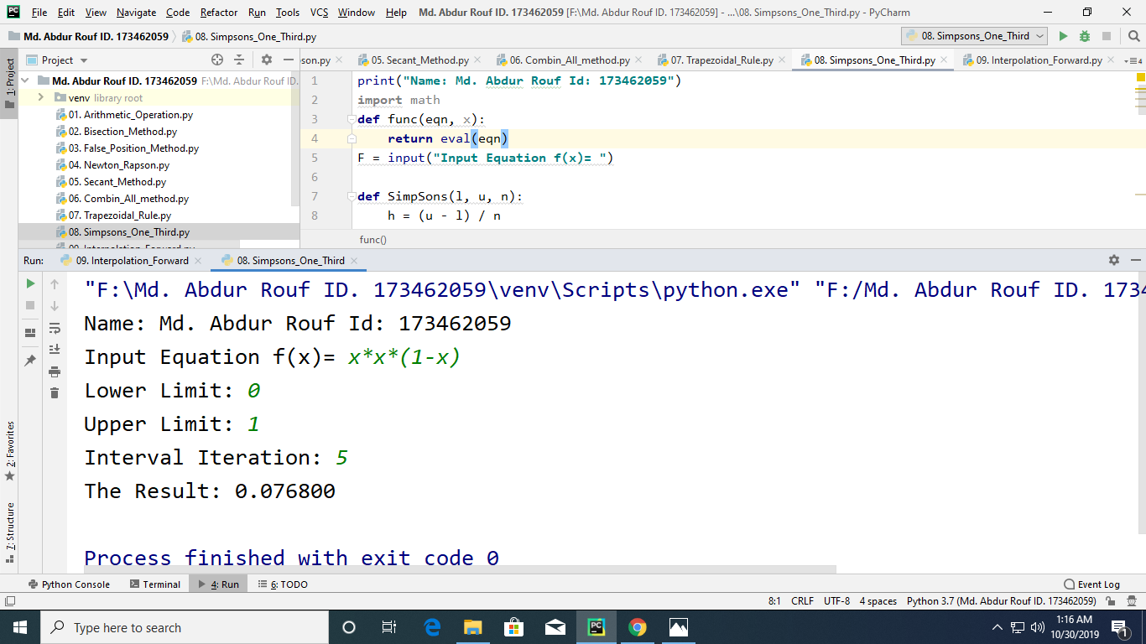

Figure: Implementation of Output Simpsons One-Third Rule in Python

**Output:**

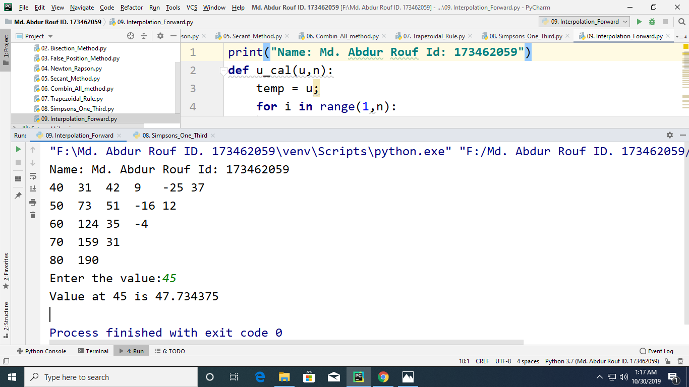

Figure: Implementation of Output Newton’s Interpolation forward in Python